Lab 07 – Exercise 1: Exception Handling
Aim: To demonstrate how Java handles invalid input and division by zero using exception handling.
Source Code
Main.java

package lab07exceptionhandling;

import java.util.InputMismatchException;
import java.util.Scanner;

public class Main {

public static void main(String[] args) {

Scanner scanner = new Scanner(System.in);

try {
System.out.print("Enter the first integer: ");
int first = scanner.nextInt();

System.out.print("Enter the second integer: ");
int second = scanner.nextInt();

int result = first / second;

System.out.println("Result: " + result);

} catch (InputMismatchException e) {
System.out.println("Error: Please enter valid integers.");

} catch (ArithmeticException e) {
System.out.println("Error: Cannot divide by zero.");

} finally {
scanner.close();
System.out.println("Program finished.");
}
}
}
Output
Test 1: Valid Input
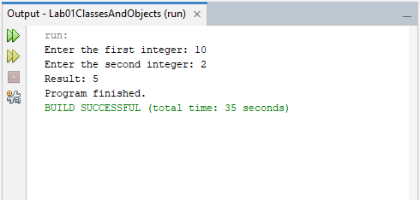
Test 2: Division by Zero
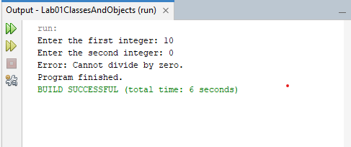
Test 3: Non-numeric input
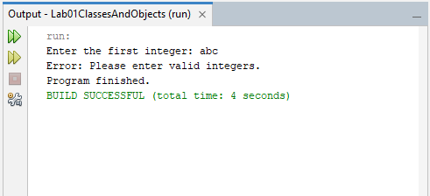
Explanation: The program used Scanner to read two integers. A try block performed the division, while InputMismatchException handled non-numeric input and ArithmeticException handled division by zero. A finally block closed the scanner and displayed a completion message.
Conclusion: Exception handling allows a program to respond to runtime errors in a controlled manner instead of terminating unexpectedly.

Exercise 2: Array Exception Handling
Aim: To demonstrate how Java handles invalid array indexes.
Source Code
Main.java

package lab07exceptionhandling;

public class Main {

// Method to access an array element safely
public static void accessElement(int[] numbers, int index) {

try {
System.out.println("Element at index "
+ index + ": " + numbers[index]);

} catch (ArrayIndexOutOfBoundsException e) {
System.out.println("Error: Index " + index
+ " is outside the array bounds.");
}
}

public static void main(String[] args) {

int[] numbers = {10, 20, 30, 40, 50};

// Valid array access
accessElement(numbers, 2);

// Invalid array access
accessElement(numbers, 7);
}
}
Output
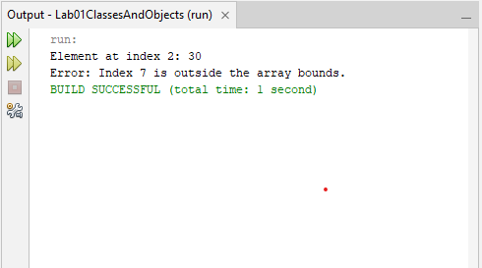
Explanation: An accessElement() method was created to retrieve an element from an integer array. A try block attempted the access, while a catch block handled ArrayIndexOutOfBoundsException when an invalid index was supplied. Both valid and invalid indexes were tested.
Conclusion: Exception handling helps prevent invalid array access from unexpectedly terminating a program.

Exercise 3: Custom Checked Exception
Aim: To demonstrate how to create and use a custom checked exception in Java.
Source Code
InvalidAgeException.java

package lab07exceptionhandling;

// A checked exception for invalid ages
public class InvalidAgeException extends Exception {

public InvalidAgeException(String message) {
super(message);
}
}
AgeValidator.java

package lab07exceptionhandling;

public class AgeValidator {

public static void validateAge(int age)
throws InvalidAgeException {

if (age < 0 || age > 120) {
throw new InvalidAgeException(
"Age must be between 0 and 120."
);
}

System.out.println("Valid age: " + age);
}
}
Main.java

package lab07exceptionhandling;

public class Main {

public static void main(String[] args) {

try {
AgeValidator.validateAge(25);
AgeValidator.validateAge(150);

} catch (InvalidAgeException e) {
System.out.println("Error: " + e.getMessage());
}

System.out.println("Program continues.");
}
}
Output
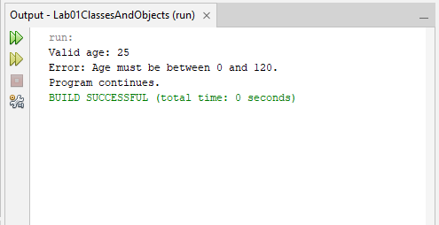
Explanation: An InvalidAgeException class was created by extending Exception. The AgeValidator class contained a validateAge(int) method that threw the exception when an age was below 0 or above 120. The main program caught the exception and displayed an error message.
Conclusion: Custom checked exceptions allow programmers to define and handle specific errors while ensuring that callers account for those errors.

Exercise 4: Custom Banking Exception
Aim: To modify a bank account withdrawal method to use a custom checked exception.
Source Code
InsufficientFundsException.java

package lab07exceptionhandling;

public class InsufficientFundsException extends Exception {

public InsufficientFundsException(String message) {
super(message);
}
}
BankAccount.java

package lab07exceptionhandling;

public class BankAccount {

private double balance;

public BankAccount(double balance) {
this.balance = balance;
}

public void deposit(double amount) {
if (amount > 0) {
balance += amount;
System.out.println("Deposited: $" + amount);
} else {
System.out.println("Deposit amount must be positive.");
}
}

public void withdraw(double amount)
throws InsufficientFundsException {

if (amount <= 0) {
System.out.println("Withdrawal amount must be positive.");
return;
}

if (amount > balance) {
throw new InsufficientFundsException(
"Insufficient funds. Available balance: $" + balance
);
}

balance -= amount;
System.out.println("Withdrawn: $" + amount);
}

public double getBalance() {
return balance;
}
}
Main.java

package lab07exceptionhandling;

public class Main {

public static void main(String[] args) {

BankAccount account = new BankAccount(100);

try {
account.deposit(50);
account.withdraw(30);

System.out.println("Balance: $" + account.getBalance());

// This withdrawal should fail
account.withdraw(200);

} catch (InsufficientFundsException e) {
System.out.println("Error: " + e.getMessage());
}

System.out.println("Final balance: $" + account.getBalance());
}
}
Output
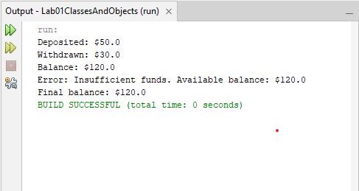
Explanation: An InsufficientFundsException class was created by extending Exception. The BankAccount class was modified so that withdraw() throws this exception when the requested amount exceeds the account balance. A try-catch block handled the failure and displayed an appropriate message.
Trade-offs: Returning false is simple and suitable for expected success or failure outcomes, but callers may ignore the result. Throwing an exception makes the failure explicit and requires callers to handle or declare it, although exceptions can add complexity when used for routine outcomes.
Conclusion: Custom exceptions provide a clear way to report specific failures while allowing the application to handle them appropriately.

Exercise 5: The Finally Block
Aim: To demonstrate that a finally block executes even when a method returns a value from its try block.
Source Code
Main.java

package lab07exceptionhandling;

public class Main {

public static int testFinally() {

try {
System.out.println("Inside try block.");
return 10;

} finally {
System.out.println("Inside finally block.");
}
}

public static void main(String[] args) {

int result = testFinally();

System.out.println("Returned value: " + result);
}
}
Output
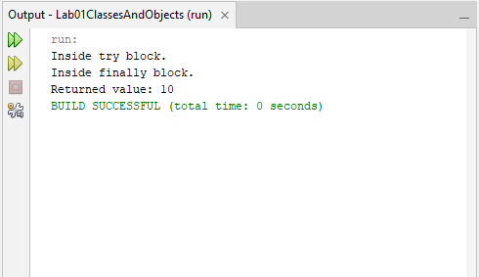
Explanation: A method named testFinally() printed a message and returned the integer 10 inside a try block. A finally block printed another message before the method completed its return. The main method then displayed the returned value.
Conclusion: The finally block normally executes before a pending return completes, ensuring that necessary cleanup or final operations can be performed. Exceptional termination of the JVM can prevent it from executing.

